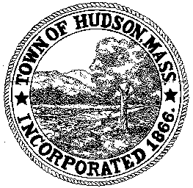

CONSERVATION COMMISSION
78 Main Street, Hudson, MA 01749
(978) 562-2020

Paul Byrne, Chairman W. Minot Wood, Vice Chairman David Esteves, Member

Terrence Joyce, Member Leif Longtine, Member Joseph Rodrigues, Member Al Tashian, Member

Meeting Agenda
February 16, 2012 7:00 P.M.

- Preliminaries
  - Open Meeting
  - Roll Call

2.0 New Business
2.1 Amendment to the Order of Conditions
DEP 190-0558
Location: 201 Manning Street
Applicant: Town of Hudson
Project Description: Construction of a new school building, and associated parking, walkways, athletic fields, and utilities

2.2 Amendment to the Order of Conditions
DEP 190-549
Applicant: Town of Hudson DPW
Location: Rolling Lane/Four Bridges Road/Rathburn Road/River Road/ Chapin Road and Brigham Street
Project Description: the installation of 4500’ of 8” gravity sewer lines, 7300’ of 6” force mains, 3000’ of 2’ and 3” low pressure sewer lines, the construction of a sewer pump station and the reconfiguration of 60’ of storm drains.

2.3 Minutes – February 2, 2012
2.4 Minutes – Executive Session February 2, 2012

2.5 MACC Membership

2.6 DPW work on Worcester Avenue

3.0 Old Business
3.1 Ft. Meadow closing spillway
3.2 54 Brook Street – start of project

4.0 Correspondence

5.0 Adjournment

Next Meeting: March 1, 2012

